Stu 1.ID: 21165827 Name 1: Lam Mei Ting Megan
Stu 2.ID: 21169718 Name 2: Ng Chui Yiu Katniss

Lab 4: Motor Driver and DC motor
Task 2 – Read the Encoder

Motor shaft rotates clockwise:
 | t0 | t1 | t2 | t3 | t4 | t5 | t6
Encoder A phase | 0 | 0 | 1 | 1 | 0 | 0 | 1
Encoder B phase | 1 | 0 | 0 | 1 | 1 | 0 | 0

Screenshot of A and B in Serial Plotter:
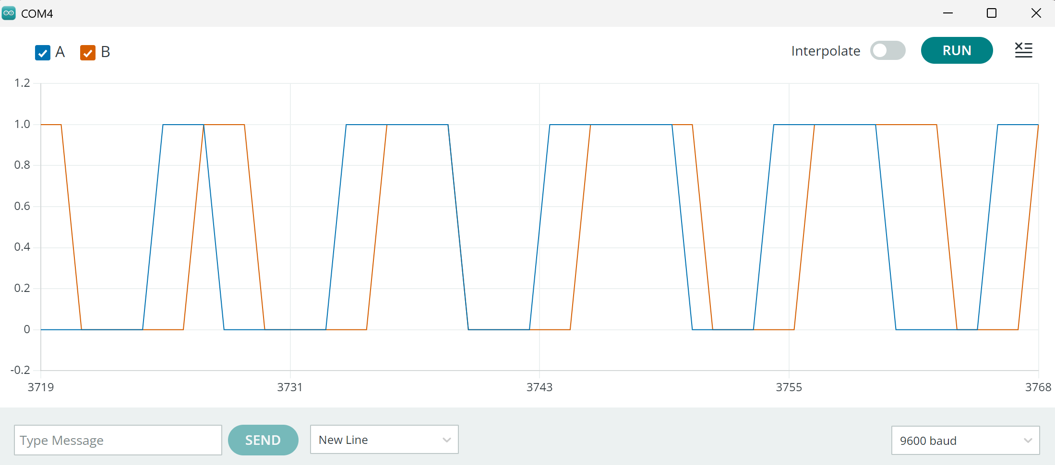

Motor shaft rotates counterclockwise:
 | t0 | t1 | t2 | t3 | t4 | t5 | t6
Encoder A phase | 0 | 0 | 1 | 1 | 0 | 0 | 1
Encoder B phase | 0 | 1 | 1 | 0 | 0 | 1 | 1

Screenshot of A and B in Serial Plotter:

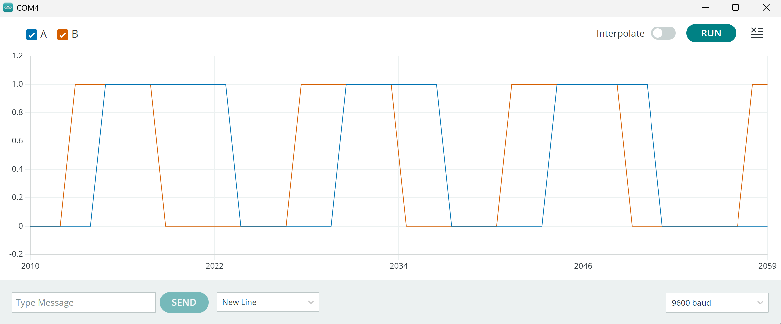

Please submit this answer sheet to Canvas/Assignment/Lab 4.

